SMART RETAIL ANALYTICS FOR FASHION SALES

Project Understanding Document

Table of Contents
Executive Summary
1. Project Overview
1.1 Problem Statement
1.2 Objectives
1.3 Key Stakeholders
2. Stakeholder RACI
3. Primary Use Cases
4. Scope
5. Target Architecture
6. Tools
7. Data Sources & Ingestion
8. Data Model
9. Pipelines & Orchestration
10. Dashboards & KPIs
11. Data Governance & Security
12. SDLC & DevOps
13. Data Population & Backfill
14. Modules & Timeline
15. Risks, Assumptions & Dependencies
16. Success Metrics & ROI
17. Glossary

Executive Summary
This project implements a scalable data engineering and analytics solution for a large fashion retail organization operating exclusively through physical stores. The retailer generates substantial POS and operational data across multiple locations, but the lack of an integrated analytics platform results in fragmented data, manual reporting, and limited business visibility.
The proposed solution centralizes raw retail data using modern cloud-based data engineering tools, transforms it into analytics-ready structures using industry-standard data models, and delivers actionable insights through interactive dashboards. By enabling sales trend analysis, inventory optimization, customer segmentation, promotion evaluation, and employee performance tracking, the solution supports data-driven decision-making, improves operational efficiency, and helps the retailer reduce revenue loss while preparing for future scalability and growth.

1.Project Overview
1.1 Problem Statement
A large fashion retail organization operates exclusively through physical stores and relies on basic Point-of-Sale (POS) systems to record daily transactions. Although high volumes of sales and operational data are generated across multiple locations, the absence of an integrated analytics platform causes data to remain fragmented, unstructured, and underutilized. Manual tracking and spreadsheet-based reporting result in limited visibility into sales trends, inefficient inventory management, frequent stockouts or overstock situations, and an inability to analyze customer behavior, employee performance, and promotion effectiveness in a timely manner. This leads to revenue loss, higher operational costs, and missed opportunities for data-driven decision-making, highlighting the need for a scalable data engineering and analytics solution.
1.2 Objectives
- To centralize offline POS and operational data from multiple retail stores into a unified data platform
- To automate data ingestion, cleansing, and transformation using scalable data engineering pipelines
- To analyze sales performance, seasonal fashion trends, and product demand patterns
- To optimize inventory levels and reduce stock-related inefficiencies
- To evaluate employee productivity, store performance, and promotion effectiveness
- To provide interactive dashboards and KPIs for management decision-making

1.3 Key Stakeholders
Key stakeholders include retail management, store managers, inventory and supply chain teams, sales and marketing teams, employees, and the data analytics team, all of whom rely on the system to improve operational efficiency and support data-driven decisions.

2. Stakeholder RACI
R = Responsible, A = Accountable, C = Consulted, I = Informed
Activity | Sponsor | Product Owner | Data Owners | Data Engineering | BI Team | Security
Project approval & funding | A | I | I | I | I | I
Requirements & KPI definition | I | A/R | C | C | C | I
Source data ownership | I | C | A/R | I | I | I
Data ingestion & processing | I | C | C | A/R | I | I
Data modeling & KPIs | I | C | C | A/R | C | I
Dashboard & reporting | I | C | C | C | A/R | I
Data quality validation | I | C | A | R | C | I
Security & access control | I | I | I | C | C | A/R
UAT & business sign-off | I | A/R | C | I | I | I
Production release | I | A | I | R | R | C

3. Primary Use Cases
- Sales Performance Analysis
Enable management to track store-wise, category-wise, and time-based sales trends using centralized POS data to identify high-performing products, seasonal demand patterns, and revenue gaps.
- Inventory Optimization
Monitor stock levels across physical stores to reduce stockouts and overstock situations by analyzing sales velocity, replenishment cycles, and historical demand patterns.
- Promotion & Store Profitability Insights
Evaluate the effectiveness of discounts and promotions, measure store-wise profitability, and support data-driven decisions for pricing and promotional planning.

4. Scope
The scope of this project includes collecting offline POS and operational data from multiple physical stores, performing data ingestion, cleaning, transformation, and modeling, and storing it in a centralized data warehouse. The project focuses on building analytical dashboards and KPI reports for sales, inventory, and promotions. Advanced features such as real-time analytics, online sales integration, and predictive AI models are considered out of scope.

5. Target Architecture
Data flows from source systems into Bronze (raw), Silver (cleaned and standardized), and Gold (analytics-ready) layers using Azure Data Factory and Databricks/Synapse Spark. Gold-layer data is served through Azure Synapse SQL to Power BI dashboards with role-based access control.

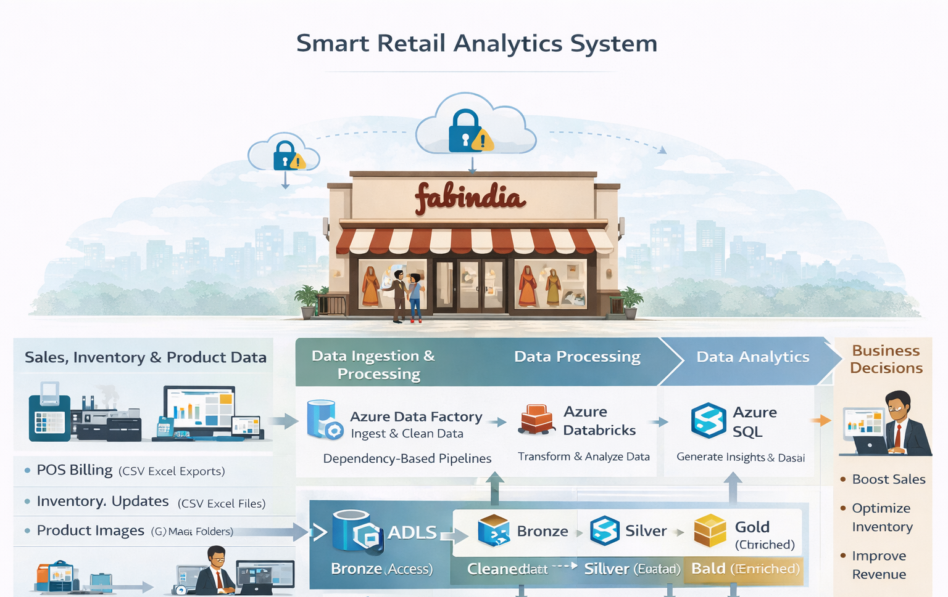
6. Tools Used
- POS System (Offline) – Generates daily sales, billing, and payment data
- Microsoft Excel / CSV – Source format for POS, inventory, employee, and supplier data
- Azure Data Factory (ADF) – Data ingestion, scheduling, and orchestration
- Azure Data Lake Storage Gen2 (ADLS) – Centralized raw and processed data storage
- Azure Databricks – Data cleaning, validation, transformation, and enrichment
- Azure Synapse Analytics (SQL Pool) – Data warehouse for analytics
- Power BI – Interactive dashboards and business reporting
- Azure Active Directory (AAD) – Role-based access and security
7. Data Sources and Ingestion
- Sales Data – POS transactions (offline billing data)
- Product Data – Product catalog, categories, pricing
- Customer Data – Loyalty / walk-in customer details
- Inventory Data – Stock levels, replenishment records
- Employee Data – Cashier and store staff performance
- Store & Branch Data – Store location and hierarchy
- Promotion Data – Seasonal offers and discounts
- Supplier Data – Vendor and procurement details
Ingestion Approach
- Data is exported daily in Excel/CSV format from POS systems
- Azure Data Factory loads files into ADLS Bronze layer
- Supports batch ingestion (daily / hourly depending on data)
- Schema validation and basic checks during ingestion

8. Dimensions
- dim_date – Calendar attributes (day, month, quarter, year, season)
- dim_product – Product details (SKU, category, brand, size, color)
- dim_customer – Customer profile (loyalty, demographics, segment)
- dim_store – Store information (store, city, region)
- dim_branch – Branch hierarchy for stores
- dim_employee – Cashier and sales staff details
- dim_promotion – Discount and campaign information
- dim_supplier – Vendor and procurement details
- dim_inventory – Stock attributes and thresholds

Facts & Grain
- fact_sales – Per product per store per transaction per day
- fact_inventory – Per product per store per day
- fact_customer_behavior – Per customer per transaction
- fact_employee_performance – Per employee per shift per day
- fact_promotion_effectiveness – Per promotion per product per day
- fact_supplier_procurement – Per supplier per product per order
9. Pipeline Orchestration
- Tool Used: Azure Data Factory / Databricks Workflows
- Orchestration Flow:
  - Schedule daily batch ingestion from offline POS systems
  - Trigger Databricks notebooks for data cleansing, validation, and transformations
  - Load curated data into Data Warehouse (Star/Snowflake schema)
  - Perform data quality checks (nulls, duplicates, schema validation)
  - Refresh Power BI datasets automatically after pipeline completion
- Monitoring:
  - Pipeline execution status
  - Failure alerts and retry mechanisms
  - Data freshness tracking

10. Dashboards and KPIs
Key Dashboards
- Sales Performance Dashboard
- Inventory & Stock Optimization Dashboard
- Customer Insights Dashboard
- Employee Performance Dashboard
- Promotion Effectiveness Dashboard
Key KPIs
- Total Sales Revenue
Overall revenue generated across all stores and time periods.
- Sales Growth Rate (%)
Measures improvement or decline in sales compared to previous periods.
- Stock Turnover Ratio
Efficiency of inventory movement (low value signals overstock risk).
- Stockout Rate (%)
Frequency of unavailable fast-moving products causing lost sales.
- Dead / Slow-Moving Inventory Value
Value of products with little or no sales over a defined time window.

11. Data governance and Security
- Data ownership defined by business domain (Sales, Inventory, HR, Store Ops)
- Business and technical metadata cataloged using Azure Purview
- End-to-end data lineage tracked from POS source to Power BI dashboards
- Role-Based Access Control (RBAC) integrated with Azure Active Directory
- PII masking applied to customer and employee data
- Change Control Board (CCB) governs schema, KPI, and pipeline modifications

12. SDLC & DevOps
- Separate environments maintained for Development, Testing, and Production
- Feature-branch development with pull request (PR) reviews and approval workflows
- CI/CD pipelines for Azure Data Factory, Databricks (Spark), Synapse SQL, and Power BI
- Version-controlled deployments with Git tags and backup-based rollback strategies
- Continuous monitoring of pipeline failures, data freshness, performance, and cost usage

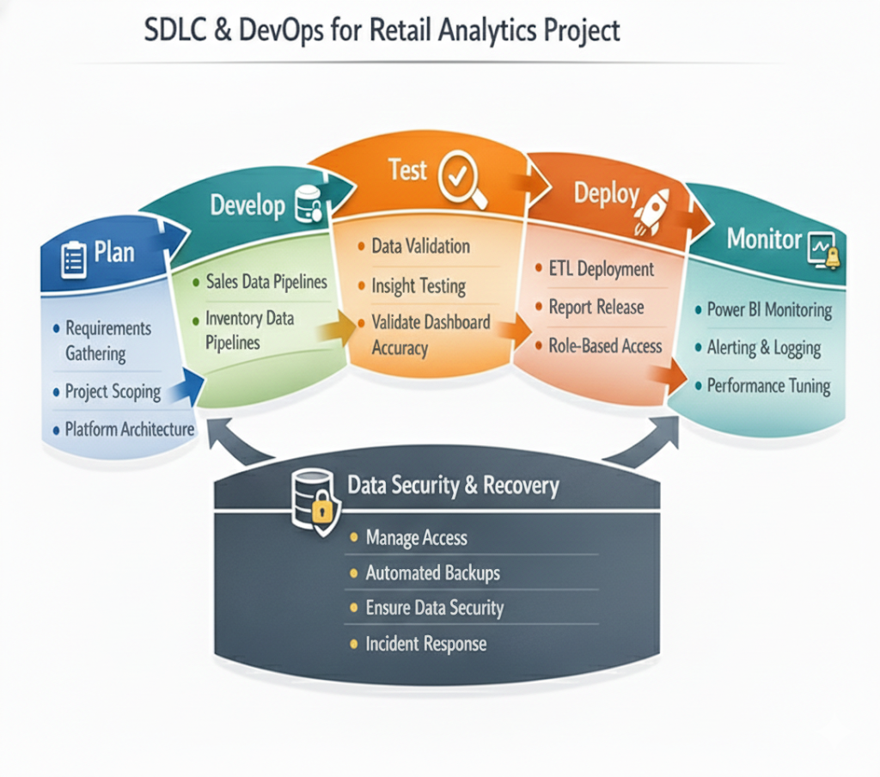
13. Data Population & Backfill
- Initial backfill of 6–12 months of historical POS and inventory data
- Daily incremental data loads using transaction timestamp and watermarking
- Handling late-arriving sales and inventory adjustments with reconciliation checks
- SCD Type 2 applied for Product, Store, Employee, and Promotion dimensions

14. Modules & Timeline
- Weeks 1–2: Architecture finalization and environment setup
- Weeks 3–5: POS, inventory, and master data ingestion to Bronze layer
- Weeks 6–8: Data cleansing and dimension modeling in Silver layer
- Weeks 9–11: Fact table creation, KPI calculations, and business logic (Gold layer)
- Weeks 12–14: Power BI dashboard development and UAT
- Weeks 15–16: Production rollout, documentation, and user training

15. Risks, Assumptions & Dependencies
- Risks: Incomplete historical POS data, schema changes, delayed access approvals, data quality issues, low dashboard adoption
- Mitigations: Data profiling, schema validation, early stakeholder approvals, data quality checks, training sessions
- Assumptions: Business SME availability, Power BI tenant access, stable POS data feeds
- Dependencies: Store IT teams, POS vendors, master data availability, Azure infrastructure readiness

16. Success Metrics & ROI
- 50–60% reduction in manual reporting effort
- Same-day availability of sales and inventory KPIs
- Reduced stockouts and overstock situations through predictive insights
- Improved promotion effectiveness and inventory planning
- Faster and more accurate store-level decision-making

17. Glossary
- POS – Point of Sale
- SKU – Stock Keeping Unit
- ABV – Average Basket Value
- SCD – Slowly Changing Dimension
- ADF – Azure Data Factory
- RBAC – Role-Based Access Control

